SIMATS ENGINEERING (SAVEETHA SCHOOL OF ENGINEERING) Department of Computer Science and Engineering
ASSESSMENT TOOL 2 – Pseudocode Writing Task
Course Code: | CSA06 | Course Title: | Design and Analysis of  Algorithms
CO Assessed: | CO5 – Naturalization (BL5, BL6) | Assessment: | Assessment Tool 2 –  Pseudocode Writing Task
Weightage: | 30% of CIA | Total Marks: | 100
CO5 Statement: | Analyze computational problems using backtracking techniques and complexity classes such as P, NP, NP-Hard, and NP-Complete for combinatorial problem solving.
Student Name: | Ishwariya P | Reg. No.: | 192524445
Section / Batch: | 2025 | Date: | 26/8/26

Instructions to Students
• Answer the following question with proper pseudocode and logical explanation.
• Clearly specify the algorithmic approach and complexity class wherever applicable.
• Use proper asymptotic notation (Big-O, Big-Θ, Big-Ω) for complexity analysis.
• Include state-space representation, recursion steps, and pruning conditions in backtracking problems. • Neat presentation and step-by-step justification are mandatory.

Question Type | Focus Area | Questions
Pseudocode Writing Task | Analyze combinatorial problems using backtracking and complexity classes such as P, NP, NP-Hard, and NP-Complete. | Q1

SECTION A – Pseudocode Writing Task
Code of Conduct
I _Ishwariya P(192524445)_________________________ (Name / Reg No) certify that this submission is my original work and that I have adhered to the guidelines specified for this assessment. I understand that any violation of academic integrity rules will result in disciplinary action.
Signature of the Student: _________________________

RUBRICS FOR CALCULATION
Criteria | Weight  age | Level 4 –  Exemplary | Level 3 –  Proficient | Level 2 –  Developing | Level 1 –  Beginning
Problem  Understanding | 20% | Identifies all inputs, outputs, constraints accurately | Minor missing  elements | Partial  understanding | Incorrect  interpretation
Algorithm  Design | 30% | Complete, correct, and logically sound solution | Minor logical gaps | Partially correct logic | Incorrect  approach
Use of Control Structures | 20% | Efficient and  appropriate use of loops, conditions,  functions/modules | Minor inefficiencies | Limited or basic usage | Incorrect or  missing  constructs
Pseudocode  Structure | 10% | Well-structured,  clear, consistent  format, easy to follow | Mostly clear with minor issues | Difficult to follow in parts | Poorly  structured  and unclear
Completeness | 20% | Handles all cases; optimized approach | Handles most  cases; reasonable efficiency | Handles basic  cases only | Incomplete or inefficient

Marks Evaluation:

Criteria | Wt. | Level 4 –  Exemplary | Level 3 –  Proficient | Level 2 –  Developing
Problem Understanding | 20%
Algorithm Design | 30%
Use of Control Structures | 20%
Pseudocode Structure | 10%
Completeness | 20%
Total Marks (100):

Level 1 – Beginning

Faculty In-charge | Course Coordinator | Head of Department
Name: | Name: | Name:
Signature: _______________ | Signature: _______________ | Signature: _______________
Date: ___________________ | Date: ___________________ | Date: ___________________

Aim

To solve a 9×9 Sudoku puzzle using the Backtracking algorithm by filling every empty cell with a valid number while satisfying row, column, and 3×3 subgrid constraints.

Algorithm

- Read the partially filled 9×9 Sudoku grid.
- Find an empty cell containing 0.
- Try numbers from 1 to 9.
- Check whether the number is valid in:
  - The current row.
  - The current column.
  - The corresponding 3×3 subgrid.
- If valid, place the number and recursively solve the remaining puzzle.
- If no number works, reset the cell to 0 and backtrack.
- Continue until all cells are filled.
- Print the completed Sudoku grid.

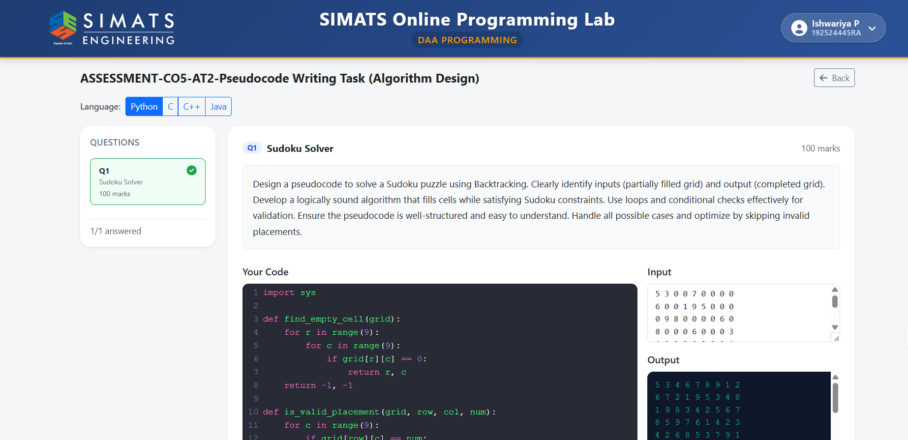

Python Code

def find_empty_cell(grid):
for row in range(9):
for col in range(9):
if grid[row][col] == 0:
return row, col
return -1, -1

def is_valid(grid, row, col, num):

# Check row
for c in range(9):
if grid[row][c] == num:
return False

# Check column
for r in range(9):
if grid[r][col] == num:
return False

# Check 3x3 box
start_row = (row // 3) * 3
start_col = (col // 3) * 3

for r in range(start_row, start_row + 3):
for c in range(start_col, start_col + 3):
if grid[r][c] == num:
return False

return True

def solve_sudoku(grid):

row, col = find_empty_cell(grid)

# Puzzle solved
if row == -1:
return True

for num in range(1, 10):

if is_valid(grid, row, col, num):
grid[row][col] = num

if solve_sudoku(grid):
return True

# Backtrack
grid[row][col] = 0

return False

# Read input
grid = []

for _ in range(9):
grid.append(list(map(int, input().split())))

# Solve and display
if solve_sudoku(grid):
for row in grid:
print(*row)
else:
print("No solution exists")

Result

For the Sudoku puzzle shown in the question, the completed grid is:
5 3 4 6 7 8 9 1 2
6 7 2 1 9 5 3 4 8
1 9 8 3 4 2 5 6 7
8 5 9 7 6 1 4 2 3
4 2 6 8 5 3 7 9 1
7 1 3 9 2 4 8 5 6
9 6 1 5 3 7 2 8 4
2 8 7 4 1 9 6 3 5
3 4 5 2 8 6 1 7 9

Thus, the Sudoku puzzle is successfully solved using backtracking while ensuring that every row, column, and 3×3 subgrid contains the numbers 1–9 exactly once.

